Explain the phenomena that happens and try to justify why this occurs.

Encrypting the large file, 200 MB text file, took a long time on my computer, here are the reasons:

Processor speed: Encrypting a file requires a lot of computational power, and my computer's processor is slow, so it will take longer to encrypt the file.

Available memory: Encryption algorithms require a certain amount of memory to operate, and if the computer does not have enough memory, it will take longer to encrypt the file.

Algorithm optimization: The efficiency of the encryption algorithm used will also impact how quickly the file can be encrypted. Some algorithms are optimized for speed, while others prioritize security. My algorithm may not be best optimized for this situation

File size: The larger the file, the more data that needs to be encrypted, and this will take longer to complete.

Encryption method: Different encryption methods have different levels of complexity, and some methods can take much longer to encrypt a file compared to others. For example, using a one-time pad encryption and 1bitCFB method encrypts and decrypt every single character or single bit of a character.

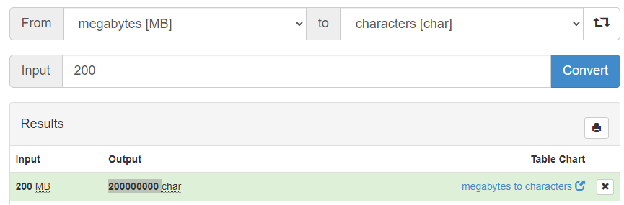

The Synchronous cipher has to encrypt estimated 100000000 characters while the 1bit-CFB has to encrypt 100000000 \* 8 as each character has 8 bits. Decrypting will take the same amount of time as encrypting. Therefore, it will take a very long time to encrypt and decrypt with a normal computer and a not optimized algorithm